**Figures are not drawn to scale.**

**Choose the letter of the correct answer. In all cases, NOTA means “none of these answers”.**

1. Nathan is at the Great Pyramid of Giza, which is approximately a square pyramid. The side of the base is $756$ feet long and the height is $455$ feet. The approximate volume of the pyramid is $86,682,960$ cubic feet. If the Egyptians had built the side of the base to be instead $1,512$ feet long, what would have been the volume of the pyramid, in cubic feet?

**A) $2(86,682,960)$ B) $4(86,682,960)$ C) $\frac{1}{2}(86,682,960)$**

**D) $3(86,682,960)$ E) NOTA**

1. Grace drew a quadrilateral on papyrus with two pairs of congruent sides.   
   Which of the following could Grace not have drawn?

**A) Kite B) Rectangle C) Square D) Parallelogram E) NOTA**

1. Nomadic Danny is traveling the arid Saharan Desert. He says, “If it does not rain today, I will save my Snapple for later.” Which of the following is logically equivalent to his statement?

**A) If it rains today, I will not save my Snapple for later.**

**B) If I save my Snapple for later, it doesn’t rains today.**

**C) If I do not save my Snapple for later, it rains today.**

**D) If it rains today, I will save my Snapple for later.**

**E) NOTA**

**For questions 4 and 5 use the following information:**

*Wayne threw a circular frisbee that got stuck on the top of Mt. Kilimanjaro. Because of the change in temperature, the frisbee uniformly shrank into a frisbee of smaller size.*

1. What is this transformation called in mathematics?

**A) Dilation B) Reflection C) Translation D) Inflection E) NOTA**

1. In geometric terms, what are the new and original frisbees called?

**A) Indistinguishable B) Similar C) Coextensive D) Congruent E) NOTA**

1. While driving on a road in Accra, Ghana, Keven slams on the breaks in front of a stops sign. Stop signs in Ghana are in the shape of a regular octagon. A side of the octagon is $\sqrt{2}$ decimeters long. What is the area of the stop sign on the face that Keven can see?

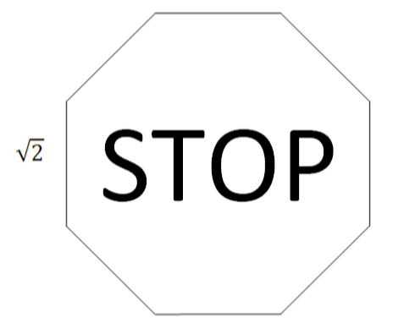

**A) $16$ B) $14$ C) $10+4\sqrt{2}$ D) $4+4\sqrt{2}$ E) NOTA**

1. Nicholas is bored and plots a graph in the sand. What is the slope of his graph $\frac{5}{x}+\frac{4}{y}=\frac{3}{xy}$, where $x,y≠0$?

**A) $\frac{3}{4}$ B) $-\frac{4}{5}$ C) $-\frac{3}{4}$ D) $\frac{5}{4}$ E) NOTA**

1. Queen Hapshetsut erected two obelisks at the entrance of the Temple of Karnak in Egypt. Traveling in Karnak, Elizabeth thought she saw the Washington Monument! It turns out to just be one of the obelisks. She notes that the obelisk has $9$ vertices and $16$ edges.

How many faces does the obelisk have? Include all faces.

**A) $4$ B) $6$ C) $8$ D) $9$ E) NOTA**

1. Many of the great ancient geometers studied at Alexandria, Egypt. Which famous Alexandrian geometer wrote the *Elements*, a collection of 13 books and 465 propositions on mostly geometry?

**A) Pythagoras B) Archimedes C) Euclid D) Apollonius E) NOTA**

1. The Sphinx asked Kenneth, “Which of the following are true?”

I) Two lines that never intersect are parallel. II) Two lines will define a plane.

III) Three points are always coplanar.  
What should Kenneth respond?

**A) III only B) I and II only C) I and III only D) I, II, and III E) NOTA**

1. Jimmy sees the following shape on a pothole in Kenya. He somehow realizes that the longest line segment that can fit in the shaded region is $\sqrt{52}$ feet long.

What is the area of the shaded region (the area between the two concentric circles)?

**A) $9π$ B) $15π$ C) $4π$ D) $π\sqrt{13}$ E) NOTA**

1. Gangplank the Pirate just landed on Robben Island in South Africa. He has to take down his triangular mast and fold it once into a right isosceles triangle. If the three sides of the original mast are $100$, $100$, and $100\sqrt{2}$ feet long. How much area is the folded mast going to take up, in square feet? Hint : Think in only two dimensions.

**A) $5000$ B) $2500$ C) $5000\sqrt{2}$ D) $2500\sqrt{2}$ E) NOTA**

1. Bill travels to Morocco and in front of him is the gate *Bab Agnaou* and there are 18 other identical gates to enter the city of Marrakech, but many have deteriorated throughout history. The gate in front of Bill has a surface area of $900$ square feet. What was the original total surface area of all the gates of Marrakech, in square feet?

**A) $27,000$ B) $16,200$ C) $17,100$ D) $18,000$ E) NOTA**

1. King Mansa Musa of the Mali Empire wonders about the following figure.

The areas of $∆COE \text{and}$ $∆AOE$ are equal, the areas of $∆CFA\text{ and} ∆CFB$ are equal.

And the areas of $∆AOC\text{ ,} ∆AOB$, and quadrilateral $AEOF$ are equal.

If the area of $∆DOB=k$, in terms of $k$, what is the area of $∆COD$?  
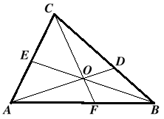  
**A) $k$ B) $\frac{3}{2}k$ C) $\frac{4}{3}k$ D) $\frac{3}{4}k$ E) NOTA**

1. Mrs. Kelley, Mr. Friedlander, and Mr. Wiggins stand in various places on the shore of Lake Victoria, forming the 3 vertices of a triangle. They realize that in a Cartesian plane they are at the points $(3,2)$, $(-4,0)$, and $(8,-2)$. What is the area of that triangle?

**A) $19$ B) $15$ C) $8$ D) $0$, the points are collinear E) NOTA**

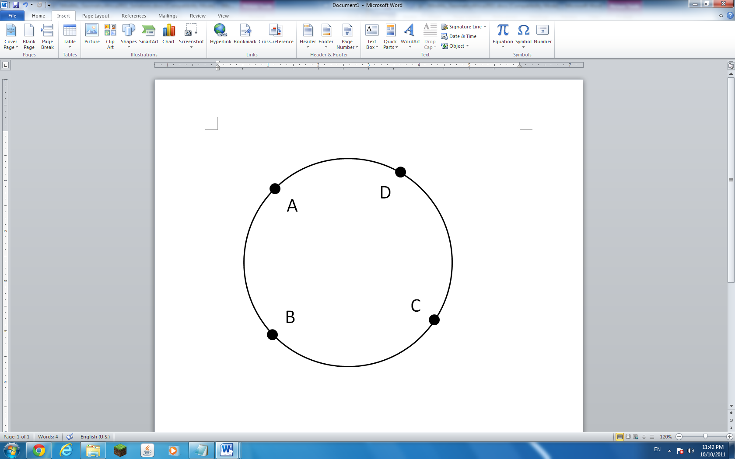

1. A student gets lost inside the city of Timbuktu. The three teachers end up finding him on a circular track with radius of $200$ meters. In the figure to the right, point $A$ is the student and points $B,C, \text{and }D$ are the teachers. They know that $BC=AB=300$ meters and that $CD=AD=200$ meters. What is the straight line distance between the points $A$ and $C$, in meters?

**A) $200$ B) $240$ C) $300$ D) $400$ E) NOTA**

1. Ginger is making triangles with Egyptian rope. Two sides of her triangle have lengths $n$ and $2n$, where $n$ is a positive integer. How many integral lengths are possible for the third side?

**A) $n$ B) $n-1$ C) $n+1$ D) $2n$ E) NOTA**

1. Jeremy stands under the Clock Tower in Cape Town, South Africa. He reads the time right when the clock turns 7:45. What is the supplement of the complement of the smaller angle between the hour and minute hands, in degrees?

**A) $150°$ B) $172.5°$ C) $120°$ D) $127.5°$ E) NOTA**

1. Nicolas Cage discovers a weird figure on a scroll in the Library of Alexandria. The figure is a circle inscribed in a regular 19-gon. He measures the perimeter of the 19-gon to be $12.68$ inches and the radius of the circle to be $2$ inches. What is the area of the region outside the circle but inside the 19-gon, in square inches?

**A) $6.34-2π$ B) $24.68-4π$ C) $\frac{\sqrt{317}}{2}-\frac{11}{4}π$ D) $12.68-4π$ E) NOTA**

1. A Nigerian prince offers you a huge sum of money. He claims he will give you twice the geometric mean of $\$25,000$ and a cost that you have to pay to receive his money. If only whole number of dollars can be in the transaction, how much should you pay to maximize your profit?

**A) $\$25,000$ B) $\$500$ C) $\$10$ D) $\$5$ E) NOTA**

1. Around 300 BC in Alexandria, what type of proof was used to prove that there an infinite number of primes? It was one of the first recorded of its kind, written down in the *Elements*.

**A) Exhaustion B) Induction C) Transposition D) Construction E) NOTA**

1. Somewhere in Egypt, Mrs. Kelley sees Mr. Kelley 25 feet away and Ron Clark $20$ feet away in another direction. Between Mr. Kelley and Ron Clark is a camel, so the three are collinear. From Mrs. Kelley’s perspective, the angle between Mr. Kelley and the camel is equal to the angle between Ron Clark and the camel. If the camel is $16$ feet away from Ron Clark, how far is Mr. Kelley from Ron Clark, in feet?

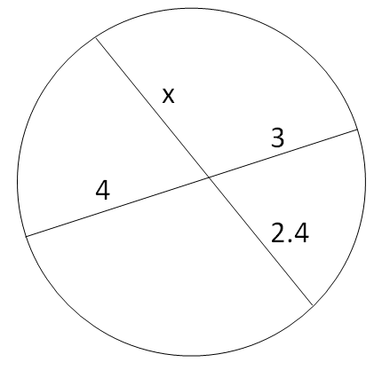  
**A) $\frac{125}{4}$ B) $20$ C) $\frac{48}{5}$ D) $36$ E) NOTA**

1. Amanda just ordered a pizza from Cleopatra’s Pizzeria that was cut into 4 pieces. Assume the pizza is a perfect circle and only 2 chords were made to cut the pieces. What is $x$?

**A) $3$ B) $\frac{9}{5}$ C) $5$ D) $\frac{20}{9}$ E) NOTA**

1. Unfortunately, Kenneth missed the Sphinx’s earlier question (#10). So the Sphinx gave him another chance to redeem himself and asked Kenneth to do three things:

I) Find a cube with double the volume of any given cube  
II) Trisect any given angle  
III) Find a square with the same area of any given circle

Which of the above is *not possible* for Kenneth to do with only a compass and a straightedge?

**A) I and II only B) III only C) I and III only D) I, II, and III E) NOTA**

1. Askia the Great of the Songhay Empire wanted to cast some gold into right triangles for decoration. He wants the triangle to have integer side lengths. Let $∆ABC$ be the triangle that requires the least amount of gold for a given thickness. What is the sum of the legs of $∆ABC$?

**A) $7$ B) $12$ C) $14$ D) $24$ E) NOTA**

1. The Pentagon plans military operations in Libya. Allison has a model of the Pentagon, which is regular pentagon inside a regular pentagon. The outer pentagon has apothem length of $20$ and the inner pentagon has apothem length of $10$, and the area between the pentagons is $k$. What is the outer perimeter of the model Pentagon, in terms of $k$?

**A) $\frac{2}{15}k$ B) $\frac{2}{5}k$ C) $\frac{1}{10}k$ D) $\frac{1}{2}k$ E) NOTA**

1. Andrew looks on the map of Africa and sees quadrilateral symbol. He thinks the symbol is a parallelogram. Which of the following by itself will prove that the symbol is a parallelogram?

I) Two pairs of sides are congruent  
II) Two pairs of sides are parallel  
III) Two sides are congruent and the other two are parallel.

**A) I, II, and III B) I and II only C) II only D) II, and III only E) NOTA**

1. Eratosthenes sees a triangle formed by the lines $2x-y=2$, $x+y=7$, and $x+4y=10$, and wants to find the centroid. What is the sum of the $x$ and $y$ coordinates of the centroid?

**A) $\frac{11}{3}$ B) $3$ C) $4$ D) $\frac{4}{3}$ E) NOTA**

1. What is the $m∠B$ in $∆ABC$?

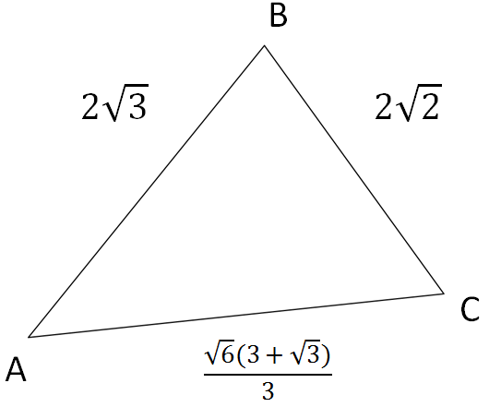

**A) $90°$ B) $75°$ C) $60°$ D) $45°$ E) NOTA**

1. For the following truth table, what symbol should ☺ be replaced with?

|  |  |  |
| --- | --- | --- |
| $$p$$ | $$q$$ | $$p☺q$$ |
| T | T | T |
| T | F | F |
| F | T | F |
| F | F | F |

**A) $⋀$ B) $⋁$ C) $→$ D) $¬$ E) NOTA**